Contents
Introduction 3
Introduction 3
Chapter 2 5
Review of Others Work 5
2.1 Introduction 5
2.2 Similar Approaches 5
2.2.1 Waze application 5
2.2.2 INRIX application 6
2.2.3 MY-TRAFFIC 6
2.2.4 Traffic, Radars & GPS-Glob 7
Chapter 3 9
Technology Adapted 9
3.1 Introduction 9
3.2 Technologies used in “analyzing traffic condition” 9
3.2.1Android Studio 9
3.2.2 Hyper Text Markup Language 5 (HTML5) 9
3.2.3 Cascading Style Sheets (CSS) 10
3.2.4CorelDraw CS6 10
3.2.5 Complex Event Processor(CEP) 10
3.2.6 Agile Development Methodology 11
Chapter 4 13
Our Approach 13
4.1 Introduction 13
4.2 Technical Approach to “analyze traffic condition” 13
4.2.1Location Detecting Strategies 13
4.2.1.1Usage geofencing anf level of service to calculate traffic 14
4.2.2 Speed detecting strategy 17
4.2.3 Analyzing Data 17
4.2.4 Mobile application 18
4.2.5 Web application 18
Chapter 5 19
Analysis and Design 19
5.1Introduction 19
5.2Analysis 19
5.2.1Requirement Analysis 19
5.3Design 20
5.3.1Database Design 20
5.3.2Graphical User Interface (GUI) Design 20
5.3.3System Architecture Design 21
Summary 22
Chapter 6 23
Implementation 23
6.1Introduction 23
6.2.1Implementation of the CEP query 23
6.3 Implementation of the android application 29
6.4 Implementation of the website 30
Chapter 7 31
Evaluation 31
7.1 Introduction 31
7.2. Evaluation of results 31
7.2 Output of the CEP using geo-fencing and LOS 32
7.2.1Get all traffic status data 32
7.2.2Get traffic for specific junction: 33
7.2.3All traffic(only traffic info): 33
7.2.4Traffic for specific junction (only traffic info): 34
Chapter 8 39
Conclusion & further work 39
8.1 Introduction 39
8.2 Achievements of Objectives 39
References 41
Appendix i 42
Appendix ii 47
Individuals contribution to the project 47

Chapter 1

Introduction

1.1Introduction
Congestion isolates people from business activities because due to the traffic condition employees always arrive late for work. Therefore it creates a less productive work force who are frustrated and tired at the beginning of the day . They cannot work efficiently and effectively the rest of the day. And too often they are tensed when they get to work.

The first thing many people think of when it comes to congested roadways is the delay. During the morning commute there is additional stress because delays caused by traffic can make people late for work. A secondary effect of traffic congestion related to delays is the inability to estimate travel times. Those who regularly travel congested areas know approximately how long it usually takes to get through a particular area depending on the time of day or the day of the week. These experienced city drivers have to build in time "just in case" the traffic is bad. The stopping and starting in traffic jams burns fuel at a higher rate than the smooth rate of travel on the open highway. This increase in fuel consumption costs commuters additional money for fuel and it also contributes to the amount of emissions released by the vehicles. Therefore lack of information about current traffic condition has caused lot of problems in day to life of people.

As a solution for the above mentioned problems this report refers to a development of a mobile application and a website which can be used to get the reliable traffic data in certain areas. The main source of data is GPS data received form the smart phone. From those it would be possible to identify the location and the moving speed of the vehicle. Therefore the users of this application have to log in to the application in their smartphones that displays crowd sourced data about traffic flows in the area whenever they travel. GPS data will be analyzed via CEP. After analyzing the data accordingly then they are displayed on a map in the android smart phone as well as on a website.
This paper will first investigate a comparison study which will be discussed together with similar approaches done by others. Then the technologies adapted and a summarize of the process of analyzing the traffic condition ,the development of android application and the website will be discussed. Next the evaluation of the results and conclusion will be discussed. Finally, suggestions for further research on the matter will be offered.

Chapter 2

Review of Others Work

2.1 Introduction
This chapter will present the systems that are similar or within the study area of the “analyzing traffic data” system, the technologies, frameworks they have used. While describing them it will include the similarities and differences of those system comparisons to “analyzing traffic data” system and the drawback and the advantages which have arisen due to those.

2.2 Similar Approaches

This is a brief overview of the similar systems and a discussion about the features developed which are different from “analyzing traffic data” system, the privileges those changes have brought to this system and the drawbacks that are arisen due to them.
- Waze application
- INRIX application
- MY-TRAFFIC
- Traffic, Radars & GPS-Glob

2.2.1 Waze application

Waze is one of the world's largest community-based traffic and navigation apps. It is an app that gives real-time traffic information and road alerts. It's free, accurate, and feature-packed. One can use the app without an account, but setting one up does give you more options to contribute to the Waze community. Waze is all about contributing to the 'common good' out there on the road.
By connecting drivers to one another, it helps people create local driving communities that work together to improve the quality of everyone's daily driving. That might mean helping them avoid the frustration of sitting in traffic, cluing them in to a police trap or shaving five minutes off of their regular commute by showing them new routes they never even knew about.

How does it work?
After typing in their destination address, users just drive with the app open on their phone to passively contribute traffic and other road data, but they can also take a more active role by sharing road reports on accidents, police traps, or any other hazards along the way, helping to give other users in the area a 'heads-up' about what's to come.
In addition to the local communities of drivers using the app, Waze is also home to an active community of online map editors who ensure that the data in their areas is as up-to-date as possible.

2.2.2 INRIX application

INRIX® is the most accurate traffic, routing and road alert app that gives control of the commute. It chooses the fastest route and decides the best time to leave.
INRIX® crowd sources data from more than just phones. INRIX® gets GPS data from over millions trucks, cameras, road sensors, in- car navigation systems. It also tracks local events that impact traffic. This app makes it easy to report immediately and share accidents, hazards and police activity.
INRIX® traffic shows detailed traffic conditions down to 800 feet of detail and include 4 million miles of road worldwide. It can be personalized and see all news relevant to commute on one screen.
There is a Traffic Map to see current traffic conditions, incidents, construction, police and road closures. Decides fastest Routes to destinations and it sends traffic alerts for accidents and delays on the route.

2.2.3 MY-TRAFFIC

MY-TRAFFIC is a community traffic monitoring for Malaysian.It has features:
- Graphical way to view raod incidents data extracted from PLUS and LLMTraffic .
- LIVE traffic cam from PLUS and LLM(Lembaga Lebuhrya Malaysia)
- Statics reports (accident,roadblock & speed traps statistics)
- User can contribute their traffic incidents and this incident will automatically altered other traffic users.

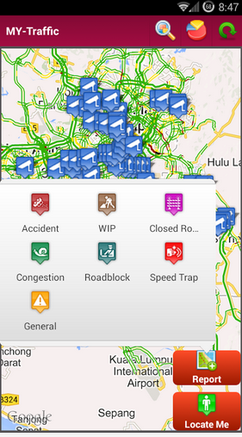
Figure 2.1

2.2.4 Traffic, Radars & GPS-Glob
Glob provides to glubbers a full set of features allowing drivers to optimize their trips. Real raod user’s community , Glob tries to show an other way of driving in safety. Glob warns you while driving close to speed cameras, speed traps, accidents or road works but allows to share favourite trips. As a single traffic info source is never enough, Glob adds its own real time crowd sourced traffic info.

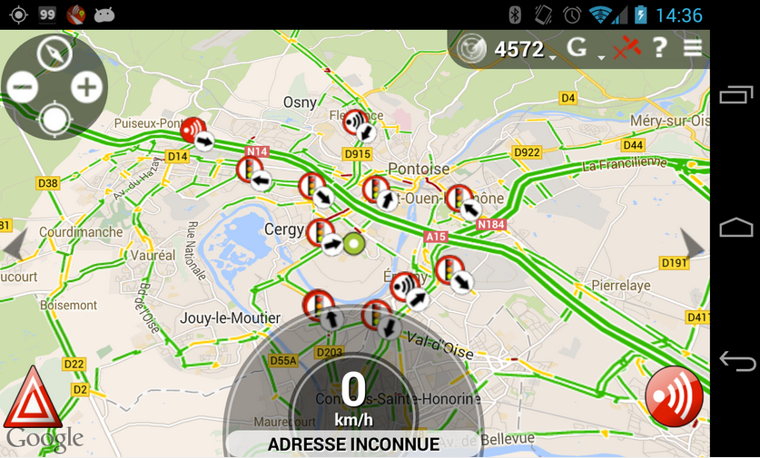

Chapter 3

Technology Adapted

3.1 Introduction
In this chapter it describes the particular technologies used in this system. Also the suitability of those adapted technologies to the system over other technologies. The frameworks and the version controllers which had been used in the system is broadly describes in this chapter.

3.2 Technologies used in “analyzing traffic condition”

3.2.1Android Studio
[1] Android Studio is the official IDE for Android application development, based on InteliJIDEA. On top of the capabilities you expect from IntelliJ, Android Studio offers:
- Flexible Gradle-based build system
- Build variants and multiple apk file generation
- Code templates to help you build common app features
- Rich layout editor with support for drag and drop theme editing
- lint tools to catch performance, usability, version compatibility, and other problems
- ProGuard and app-signing capabilities
Built-in support for Google cloud platform, making it easy to integrate Google Cloud Messaging and App Engine

3.2.2 Hyper Text Markup Language 5 (HTML5)

HTML stands for Hyper Text Markup Language. HTML5 is the latest version of the html. It is created according to more precise standards of World Wide Web consortium.
Its core aims have been to improve the language with support for the latest multimedia while keeping it easily readable by humans and consistently understood by computers and devices. In addition to specifying markup, HTML5 specifies scripting application programming interfaces (APIs) that can be used with JavaScript.

3.2.3 Cascading Style Sheets (CSS)

Cascading Style Sheets (CSS) is a style sheet language used for describing the look and format of a document written in a markup language (such as HTML).
CSS is designed primarily to enable the separation of document content from document presentation, including elements such as the layout, colors, and fonts. This separation can improve content accessibility, provide more flexibility and control in the specification of presentation characteristics, and enable multiple HTML pages to share formatting by specifying the relevant CSS in a separate.

3.2.4CorelDraw CS6

Offers an easy-to-use Site Wizard,templates,drag-and-drop functionalities and seamless integration with HTML, CSS, and java script. Corel Website creator makes it easy to build standout websites.

3.2.5 Complex Event Processor(CEP)

[2] Every enterprise's transactions and activities consist of a constant stream of events. Enterprises that monitor these events in real time and quickly respond to their environments have greater business advantage over competitors. Complex event processing is about listening to events and detecting patterns in real-time, without having to store events.
WSO2 Complex Event Processor (CEP) is a lightweight, easy-to-use, open source Complex Event Processing server (CEP) available under Apache Software License v2.0. WSO2 CEP identifies the most meaningful events within the event cloud, analyzes their impact, and acts on them in real-time. It's built to be extremely high performing and massively scalable.

Special features:
- Extremely High Performant Processing Engine:Process more than 2.5M events per sec on single-server commodity hardwarePowered by WSO2siddhi
- Powerful and Extensible Query Language for Temporal Event Stream Processing:Filter events by conditions,Join event streams and create new streams,Execute temporal queries using various windows,Detect and respond to various event patterns and sequences,Process historical data in RDBMS in real-time.
- Support for Rich Event Model
- Easily Integrates with any Enterprise System for Event Capture: RESTful HTTP protocol with JSON, XML and Text, JMS Map, JSON, XML and Text messages, SOAP over any transport protocol, Kafka, File and Email protocols with JSON, XML and Text-messages

3.2.6 Agile Development Methodology

Agile development methodology is a software development method that use to develop a software in a more precise and efficient way. We use agile scrum to develop our project.
Early implementations of agile methods include Rational Unified Process, Scrum, Crystal Clear, Extreme Programming, Adaptive Software Development, Feature Driven Development, and Dynamic Systems Development Method. These are now collectively referred to as agile methodologies.
The main purpose of using Agile Scrum is that the requirements are difficult to extract and are likely to change over the period.

Chapter 4

Our Approach

4.1 Introduction
In the previous chapter we discussed the appropriate technologies which can be used for “analyze traffic condition” system and the reasons for using such technologies in the implementation. In this chapter the focus will be basically on approaches to implement the system ,android application and website using the above mentioned technologies.
The proposed solution is basically an android application which is used to retrieve crowd source data. After receiving the relevant data they are analyzed through the CEP and visualized on a separate map application in the phone and also in the website.

4.2 Technical Approach to “analyze traffic condition”

The proposed solution comprises of android application,CEP server and a website. Users who are willing to support crowd-source their speed data can access the application through sign-up activity and the users who are not willing to support crowd-source their speed data but willing to know about current traffic condition can access the website via phones as well as via laptops.

4.2.1Location Detecting Strategies

First step was to get the users location. In order to get the user location from android smart phone we could utilize either GPS or Android's Network Location. Although GPS is most accurate, it only works outdoor; it quickly consumes battery power, and doesn't return the location as quickly as users want.
Getting user location in Android works by means of callback. It involves two classes as LocationManager and LocationListener. We receive location updates from the LocationManager ("Location Manager") by calling requestLocationUpdates (), passing it a LocationListener. LocationListener must implement several callback methods that the Location Manager calls when the user location changes or when the status of the service changes.
The first parameter in requestLocationUpdates () is the type of location provider to use (in this case, the Network Location Provider for cell tower and Wi-Fi based location). With the second and third parameter we can control the frequency at which the listener receives updates—the second is the minimum time interval between notifications and the third is the minimum change in distance between notifications—setting both to zero requests location notifications as frequently as possible. The last parameter is the LocationListener, which receives callbacks for location updates.
Further more these predefined methods can be used to retrieve phone ID, latitude and longitude of a vehicle.
- public String getPhoneID()
- public double getLatitude():Get the latitude in degrees.All locations generated by LocationManager will have a valid latitude.
- public void setLatitude(double latitude):set latitudes in degrees.
- public double getLongitude():Get the longitude in degrees.All locations generated by LocationManager will have a valid longitude.
- public void setLongitude(double longitude):set longitudes in degrees.

4.2.1.1Usage geofencing anf level of service to calculate traffic

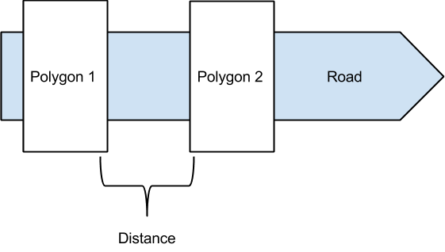

Geo fencing is a feature that can be used in a software program to define the geometrical boundaries. It uses Global Positioning System (GPS) or radio frequency identification (RFID). In our project this technology was used to segment the road. To define the boundaries and filter vehicular data, geo-fencing custom extension in WSO2 CEP is used. When CEP receives an event, its coordinates are checked against the defined boundaries to check whether it is inside or outside, using OSGeo Geo Tools library [4].

Level of service is the grading system is used to rate traffic.
There are two ways to calculate level of service of a two way highway.
- Percent time following another vehicle
- Average Travel Speed

Percent time following another vehicle - is the average time percentage of time that vehicles are travelling behind slower vehicles. When the time between consecutive vehicles is less than three seconds, the trailing vehicle is considered to be following lead vehicle.

Average Travel Speed - is the space mean speed of vehicles in the traffic stream. Space means the segment length divided by average time for all vehicles to traverse the segment in both directions during a designated interval. ATS is a measure of a degree in which the highway serves its function of providing efficient mobility.

Traffic conditions are defined according to the value of ATS. [6]
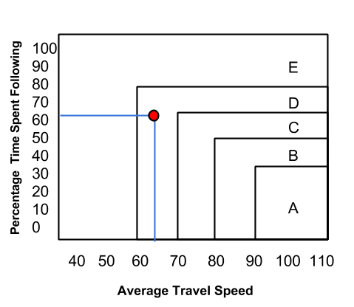
ATS = Distance / average time of vehicles

As it becomes more complex when considering the Percentage Time Spent Following, In our implementation only considered the Average Travel Speed for traffic calculations.
One execution plan includes all the required processes to calculate the traffic status of a particular junction.

4.2.2 Speed detecting strategy

Android Location API can be used to detect speed of vehicles. [3] This is a data class representing a geographic location. A location can consist of a latitude, longitude, timestamp, and other information such as bearing, altitude and velocity.All locations generated by the LocationManager are guaranteed to have a valid latitude, longitude, and timestamp (both UTC time and elapsed real-time since boot), all other parameters are optional.

- public double getSpeed():Get the speed if it is available,in meters/second over ground. If this location does not have speed then 0.0 is returned.
- public void setSpeed(double speed):set speed in meters/second over ground.

4.2.3 Analyzing Data

This is done through WSO2 Complex Event Processor (CEP) which is an open source. It is available under Apache. It identifies the most meaningful events within the event cloud, analyzes their impact, and acts on them in real-time. WSO2 CEP is built up on WSO2 Carbon platform. Web socket which is an InputEventAdaptor as well as OutputEventAdaptor can be used to input GPS data to CEP and also to output the analyzed data to a web service. Queries can be implemented using siddhi language in-order to support to the siddhi processor. TimeBatch window of 1 min can be used to calcualate average speed during every 1 min. This will output the data as a batch. Pre-defined methods such as count,avg,max can be used to following purposes.
count : take a count of occurrences.
avg : calculate average speed.
max : select maximum value of a certain category.

4.2.4 Mobile application

Mobile application was done using android SDK and coding part is done using eclipse software. Mainly this application is developed for android phones but can be used for other platforms also because of using android SDK versions greater than 2.2. Application will be designed to crowd-source traffic data and visualize them in a map. To promote the app on facebook, a facebook API will be used.

4.2.5 Web application

Website was created to the users who are not willing to contribute their gps data for crowd sourcing, but willing to know about the current traffic condition.
This website will be embed with a google map to visualize current traffic condition. So the user can log into our website and get the current traffic status. There will be some other pages in the website. Such as About us, services, home page and current traffic condition page. In about us page, user can get more details about the system. In current traffic condition page user can get the traffic condition from the google map.

Chapter 5

Analysis and Design

5.1Introduction

This chapter describes the analytical background of the project, the main structure of the designing phase.This chapter mainly describes about the analysis and design of the solution that was proposed previously. Appropriate Unified Modelling Language (UML) diagrams are used here to assist us in the analysis and designing of the CEP server,android app and website.

5.2Analysis

In the analysis stage we focused on identifying the user requirements and deciding which requirements will be fulfilled via this solution. It describes what the system is expected to do, irrespective of how we aim to implement it. A thorough understanding of the user requirements, and performance and functionalities of the existing solutions are essential for this stage to be productive.

5.2.1Requirement Analysis

Under this section a detailed system study was carried out of the existing manual system and the entire functions and operations of the system by all of the group members.
The following methodologies used for the process of gathering information.
- Interviews
- Review of the current systems available
Interviews
Interviews and discussions were carried out with the Project coordinator of WSO2 regarding their requirement.
Review of the current systems available

Interfaces and the functionalities of the current systems were reviewed to gain insight in to the process.Interviews and review of the current systems helped to identify the following problems.
- Company needed way to aware the employees about traffic condition in their daily travelling routine.
- The prevailing apps are developed for a more generic purpose.
- In the prevailing system the whole worldwide geographical area is targeted which is mostly not relevant for the company.
After gathering requirements and analyzing them system was visually modeled with the help of UML tools and OOAD concepts to get an overview of the system.
Relevant diagrams are attached in the Appendix i.

5.3Design

The system designing stage focused on the methods of which the implementation of the user requirements identified in the analysis stage.Identification of the system’s main modules and designing the activity diagrams to demonstrate the plan to implement the corresponding modules were done here.Also identified how the technologies mentioned in Chapter 3 could be used to implement the features of the system. To start off with, the overall top level design of the System is shown below.Relevant diagrams are attached in the Appendix i.

5.3.2Graphical User Interface (GUI) Design
There are two main GUIs. One is the web site and the other is the mobile application interface for android phones. We have ensured that a consistent theme and a clear structure have been followed throughout the web site as well as in the mobile application. The aim is to create user interfaces which are responsive and interactive. It should engage the user especially in the crowd sourcing process.
The user interfaces have been designed using the interface designing principles.
The designs of GUIs have been attached in appendix i.

5.3.3System Architecture Design
System Architecture Design is a major roll for any software development process. A system architecture is the conceptual model that defines the structure, behavior, and more views of a system. An architecture description is a formal description and representation of a system, organized in a way that supports reasoning about the structures and behaviors of the system.

Main modules of our system are android application, data analyzing module and database.

Android application
It is the first component to act in the processing. User interface was designed to log in to the mobile application. Being logged into the system act as a input for the data analyzing module (CEP).
User can visualize processed data sent from the CEP on a Google map. The relevant traffic conditions along with the alternative routes to be taken are displayed on the map application. Alert messages can also be viewed by the user at times needed.
The android application is written using Java Language.

Data analyzing module (CEP)
Input Event Adaptor receives events that are coming to the CEP. Event builders convert the events received by Input Event Adaptor to event streams. Event Stream Manager handles all event streams in the system. It is the central hub for all events
Event Stream Manager stores stream definitions via the Data Bridge Stream Definition Store. Event Builder, Event Processor and Event Formatter components interact with Event Stream Manager to retrieve information regarding the streams.

Event Processor handles actual event processing. It is the core event processing unit of the CEP. It manages different execution plans and processes events based on logic. Event Processor gets a set of event streams from the Event Stream Manager, processes them, and triggers new events on different event streams back to the Event Stream Manager.

Event Formatters convert the events of the event streams in to different formats. Support configurable output event mapping. Output Event Adaptor publishes events to external systems and dumps data to databases for future analysis.

Database
Processed data is stored for further analysis.

Website
Any user can be aware of the current traffic condition by using this. This visualizes the traffic condition which is analyzed by the CEP.

Summary

This chapter describes about the analysis and the designing part of the system and how each module interact with other modules. Furthermore the architecture of the proposed solution was described in this chapter. In the next chapter we focus on the implementation aspects of “crowd-sourcing traffic data”.

Chapter 6

Implementation

6.1Introduction

The previous chapter described the analysis and the designing aspects of the system, which included the modules and the interactions between them in detail. In this chapter will focus on the implementation of the discussed modules. This contains the techniques that were used to develop the system.

6.2.1Implementation of the CEP query

As the first step the road was divided into sections of 1km from katubeddata to bambalapitiya by using longitudes and latitudes of each ranges. Then queries were developed in CEP to analyze the traffic condition of each ranges.

As the first step GPS data are imported from retrieveData:2.0.0 stream and filtered.Code segment shows the how the query was developed to get the GPS data from each vehicle which belong to relevant sections.
/ Imported from retrieveData:2.0.0
define stream ret (meta_phoneID string, meta_latitude double, meta_longitude double, meta_speed double )
// Exported to individualAvgMaxData:2.0.0
define stream indi ( meta_phoneID string, meta_latitude double, meta_longitude double, meta_avgSpeed double, meta_maxSpeed double )

from ret[meta_latitude>=6.797441 and meta_latitude<6.805836
and meta_longitude<=79.888424 and meta_longitude>79.885677]#window.timeBatch( 1 min )
Select meta_phoneID,meta_latitude,meta_longitude,avg(meta_speed) as meta_avgSpeed,max(meta_speed) as meta_maxSpeed
group by meta_phoneID
insert into indi for all-events;

This query part allows to filter the relevant GPS data and calculate average speed of each individual and store the maximum speed of them. Here individuals are uniquely identified by the phone ID and timeBatch window of 1 min is used to calculate average speed during every 1 min. . Then all GPS data are exported along the individualAvgMaxData:2.0.0 stream.
individualAvgMaxData:2.0.0 stream act as an input stream to two streams such as allDataWithZeroSpeed :2.0.0 and avgSpeedInEachPart:2.0.0.

Below code segmant shows how the vehicles with average speed of zero are getting filtered and counted and exported along the allDataWithZeroSpeed:2.0.0 stream. The concept behind this was to collect and get a count of GPS data in each sections which has a zero average speed and exported to allDataWithZeroSpeed:2.0.0 stream.
// Imported from individualAvgMaxData:2.0.0
define stream indi (meta_phoneID string, meta_latitude double, meta_longitude double, meta_avgSpeed double, meta_maxSpeed double )
// Exported to allDataWithZeroSpeed:2.0.0
define stream zero ( meta_phoneID string, meta_latitude double, meta_longitude double, meta_avgSpeed double, meta_number long )

From indi[meta_latitude>=6.797441 and meta_latitude<6.805836and meta_longitude<=79.888424 and meta_longitude>79.885677 and meta_avgSpeed==0]
Select meta_phoneID, meta_latitude,meta_longitude,meta_avgSpeed ,
count(meta_phoneID) as meta_number
insert into zero;

Below code segment shows query that imported the filtered GPS data in each section and calculated the relative average speed of a vehicle in each section and exported to avgSpeedInEachPart:2.0.0 stream . Here in order to separate GPS data coming from vehicles and people who walking along the street, the maximum speed of vehicle is being used. Assuming that it is impossible for a person to exceed his speed more than 5 ms⁻¹ , the data which has maximum speed above 5ms⁻¹ are filtered here.
// Imported from individualAvgMaxData:2.0.0
define stream indi (meta_phoneID string, meta_latitude double, meta_longitude double, meta_avgSpeed double, meta_maxSpeed double )
// Exported to avgSpeedInEachPart:2.0.0
define stream av ( meta_latitude double, meta_longitude double, meta_avgSpeed double )

from indi[meta_latitude>=6.797441 and meta_latitude<6.805836
and meta_longitude<=79.888424 and meta_longitude>79.885677 and meta_maxSpeed>5]#window.timeBatch( 30 sec )
select meta_latitude,meta_longitude,avg(meta_avgSpeed) as meta_avgSpeed
group by meta_phoneID
insert into av for all-events;

Now allDataWithZeroSpeed:2.0.0 stream and avgSpeedInEachPart:2.0.0 stream is combined to calculate the average speed of each section again. Vehicle’s average speed may be zero when it is parked and also when it actually congested due to high traffic. This problem was solved by the query showed below. joiningStream:2.0.0 carries the data collected from above mentioned two streams. Below shows the execution plan to calculate the average speed of each section.
// Imported from allDataWithZeroSpeed:2.0.0
define stream zero (meta_phoneID string, meta_latitude double, meta_longitude double, meta_avgSpeed double, meta_number long )
// Imported from avgSpeedInEachPart:2.0.0
define stream part (meta_latitude double, meta_longitude double, meta_avgSpeed double )
// Exported to joiningStream:2.0.0
define stream colle ( meta_latitude double, meta_longitude double, meta_avgSpeed double )

from zero[meta_number>5]
select meta_latitude,meta_longitude,meta_avgSpeed
insert into colle;
from part

select meta_latitude,meta_longitude,meta_avgSpeed
insert into colle;

// Imported from joiningStream:2.0.0
define stream jnst (meta_latitude double, meta_longitude double, meta_avgSpeed double )
// Exported to trafficConditionWithiEachPart:2.0.0
define stream traffic ( meta_latitude double, meta_longitude double, meta_avgSpeed double )

from jnst[meta_latitude>=6.797441 and meta_latitude<6.805836
and meta_longitude<=79.888424 and meta_longitude>79.885677]
select meta_latitude,meta_longitude,avg(meta_avgSpeed) as meta_avgSpeed
insert into traffic;

Finally trafficConditionWithiEachPart:2.0.0 stream will carry the traffic condition of each section send to the web service which then send back and display in the smart phone.

6.2.2Implementation of the query using geofencing and level of service
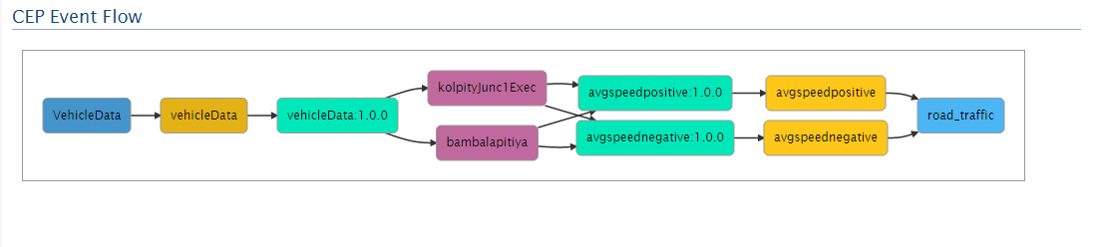
User’s imei number, longitude, latitude values are passed in to the execution plan from an event stream.

In the execution plan two polygons in one junction are defined using longitude and latitude coordinates of the road segments. When CEP receives an event check whether it is within the range of defined polygons. If they are within those polygons events are sent to two different streams based on the polygon which they belong to.

Then the entering time stamps of each individual vehicle for first polygon and the second polygon are recorded separately. And those timestamps and imei number of vehicles are passed to another stream.

After that time difference of each vehicle is calculated. If it becomes negative that indicates the vehicle is travelling to the opposite direction. From that we can separate the vehicles according to their travelling directions.

Then the average vehicle speeds of each direction are calculated and the distance of road segment is divided by it to calculate the average speed of each direction. This average speed data is then sent to a mysql database through a mysql output adapter in CEP [5].

From this average speed we can define the traffic level of each direction in application level.
Siddhi queries are shown below.

from nospeedstream[geo:iswithin(longitude,latitude,"{'type':'Polygon','coordinates':[[[79.84941602,6.91021645],[79.85038161,6.91049338],[79.85070348,6.90979042],[79.84948039,6.90930048],[79.84941602,6.91021645]]]}")==true]
select imei , longitude,latitude,timemili
insert into filteredPoly1;

from nospeedstream[geo:iswithin(longitude,latitude,"{'type':'Polygon','coordinates':[[[79.84995246,6.90819278],[79.85132575,6.90836319],[79.8514545,6.90763893],[79.85020995,6.90721289],[79.84995246,6.90819278]]]}")==true]
select imei , longitude,latitude,timemili
insert into filteredPoly2;

from filteredPoly1#window.unique(imei) as p1 join filteredPoly2#window.unique(imei) as p2
on p1.imei == p2.imei
select p1.imei as imei, p1.timemili as timemili1,p2.timemili as timemili2
insert into joinedpolydata;

from joinedpolydata#window.firstUnique(imei) as p1
select * insert into uniquejoinedpolydata;

from uniquejoinedpolydata
select imei, (timemili2-timemili1) as timediffmili
insert into timeDiffStream;

from timeDiffStream[timediffmili>0]
select imei,timediffmili as postimediffmili
insert into positivetimeDiffStream;

from timeDiffStream[timediffmili<0]
select imei,(-1*timediffmili) as negtimediffmili
insert into negativetimeDiffStream;

from positivetimeDiffStream#window.time(30 sec)
select "Kolpity" as junc_id,avg(postimediffmili) as free_flow_speed_d1
insert into avgtimediffmilistream;

from avgtimediffmilistream
select junc_id, ((1000/free_flow_speed_d1)*5/18) as free_flow_speed_d1
insert into avgspeedpositive;

from negativetimeDiffStream#window.time(30 sec)
select "Kolpity" as junc_id,avg(negtimediffmili) as free_flow_speed_D2
insert into avgtimediffmilistreamneg;

from avgtimediffmilistreamneg
select junc_id, ((1000/free_flow_speed_D2)*5/18) as free_flow_speed_D2
insert into avgspeednegative;

Adding a new Junction

When it requires adding a new junction, can do it using an Admin service to send to CEP and call it through API.

API

We are introducing a REST API to which outside apps can call and get data from the system. The API is written using WSO2 Jaggery [4]. It is possible to receive the following metrics through the REST API.

6.3 Implementation of the android application

Application was developed using android studio. In the home page, user has to tap on continue. Then it will load the map. A timer class was implemented so that it automatically repeat the sequence of calling webservce to retrieve data(currently traffic areas). Then web servlet class will be called which is created in openshift.. Like wise latitude ,longitude , speed and phoneID data wil be sent to the webservice then webservie send to the CEP , on that case webservlets are not attempt to keep any reacords update in data base. Every time CEP will retrieve requests from the users and it analyze realtime data and every 1 minites after it identifies/analyze traffic areas and send those areas and update database in the webservice.When retrieving data from the servlet there are lot of positions to retrieve. There ‘json’ library was used to get such big data efficiently,in application. A request to asyncTask should be done which is a parallel thread to main thread, its very easy to request and get response.In map case , there is some navigations to facebook to get like this application and if some user need to watch our statistics view on our webpage they can also go by clicking visit us.

6.4 Implementation of the website

This website also gives more services to the user in order to get the accurate traffic condition. In this website there are three main pages. Those are home page, about us page and current traffic condition page. From these pages user can get the result of our analyzed data.
To create that website we used bootstrap, PHP, xampp server to access the main database. First we created the web page. Then we need to visualize the traffic condition also in this website. So for that we needed to embed a Google map to our website. And the other one was we need to access the main database which was host in Openshieft through our website. From our web page we create an AJAX call to the php file which was host in xampp server. And there are local database to send our data when we registering the users. By calling that php file it retrieve the traffic data in main database.
So from that the user can get the current details about the traffic condition. Then the user can choose the best way to reach their destination with less traffic.
Chapter 7

Evaluation

7.1 Introduction

The application and the website was evaluated to see whether it meets the user requirements or not, which is the most important process of delivering the system. For the evaluation process a simple questionnaire was presented to the user to get the feedback. This questionnaire helped in rating the application and the website.
Getting feed backs from the users was important, because it helped in improving the app and website and also to identify the main drawbacks and overcome them with the use of modern technology. Main idea of introducing a new product to the market with the use of modern technology is to help the customers and users of the application to ease their work and get them done by in an effective and efficient manner. So the most important thing is the customer satisfaction. Using the questionnaire, users can evaluate the application and state whether it has fulfilled their requirements.

7.2. Evaluation of results

To evaluate the application 50 participants were used. Real time data were collected from them. They were recorded in a database. Using the recorded values clients were created. Client file was run to generate real time data and the output is shown below.

7.2 Output of the CEP using geo-fencing and LOS

7.2.1Get all traffic status data

Sample request:

GET /apis/traffic
Sample response:

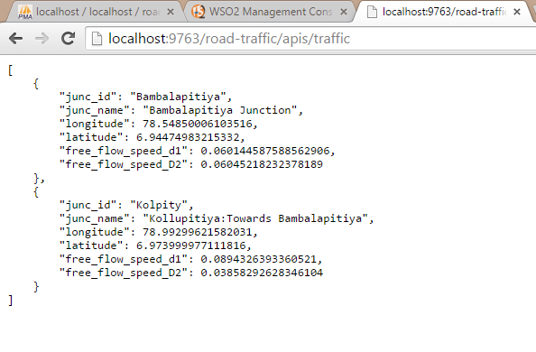

7.2.2Get traffic for specific junction:

Sample request:
GET /apis/traffic?junc_id=kolpity

junc_id : We can get traffic status in a particular junction.

Sample response :
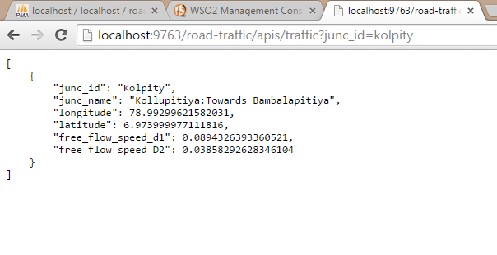

7.2.3All traffic(only traffic info):

Sample request:

GET/apis/traffic?trafficonly=true

Sample response:
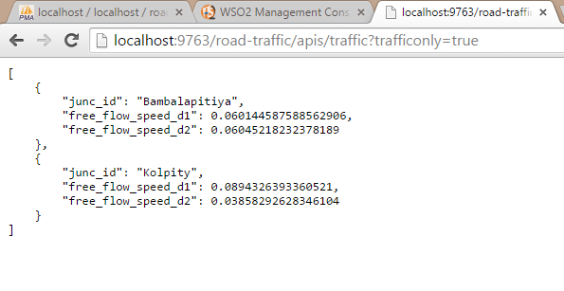

7.2.4Traffic for specific junction (only traffic info):

Sample request:

GET/apis/traffic?junc_id=kolpitycol&trafficonly=true

Sample response

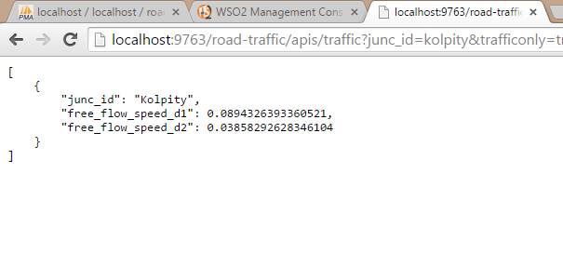

Software Product Evaluation Survey Questionnaire (Analyzing and visualizing traffic condition)

- Age of the person taking the questionnaire: years.

- Are you a current employee :
Yes No
- Are you familiar with the application?
Yes No

- Have you used any other traffic visualizing application before?
Yes No

- How satisfied are you with this web site on each of the following item?
(Put a tick mark on before of each item)

 | Very good | Good | Average | Poor | Very poor
Quality
Accuracy
Response Speed
User friendliness
Customer service

- Did the application satisfy your need?
Yes No

- What do you like/dislike about the application?

- . Do you think the proposed application will be more effective and efficient than the existing systems?
Yes No

- What is the reason for the above response?

- Would you recommend our product to anyone?
Yes No

- Why would you recommend our product?

- What suggestions do you have to improve our product?

- Thinking of similar products offered by other companies, how would you compare our product offered to them?
Perfect
Much better
Somewhat better
About the same
Somewhat worse
Much worse
Don’t know or never used

- Overall grading of the system.
Very Good | Good | Average | Poor | Very Poor

Chapter 8

Conclusion & further work

8.1 Introduction

This chapter will finalize the entire project and the report. Under this chapter it provides the references to the implementation and the outsider’s perspective about the project. In order to commercialize the application we have developed, we need to identify the barriers before it expose to the market. This kind of evaluation mainly targets the identifying of limitations of the developed software. Under this section we clarify whether we have achieved the aim with completing the object which we have identified at the beginning of the project.
Objectives we have identified at the beginning of the project are mentioned below.
- Detecting the locations
- Detecting the speed of vehicles
- A way to feed the data into the CEP
- A way to analyze the GPS data
- A way to retrieve the analyzed data from the CEP
- A way to visualize the traffic condition in the android application and in the web site

8.2 Achievements of Objectives

After referring many research articles to detect the location of a vehicle the concept of geo-fencing was applied. This was supported by the collected GPS data. Then the traffic condition was calculated through an execution plan in the CEP and a value was taken as the output to denote the traffic level. The value of the traffic level needed to be sorted out according to a standard method. Level Of Service method was selected out of the available techniques. Finally the result was published in a web service which was later fed as input to the mobile application and to website to display in the map with a relevant color.

References
[1] http://developer.android.com/tools/studio/index.html
Android 5.1 r1 — 13 May 2015 23:45
[2]https://docs.wso2.com/display/CEP310/WSO2+Complex+Event+Processor+Documentation
[3] http://developer.android.com/reference/android/location/Location.html
[4] Geo Spatial Data Analysis using WSO2 CEP
http://wso2.com/library/articles/2015/01/article-geo-spatial-data-analysis-using-wso2-co
mplex-event-processor-0/

[5] MYSQL output event adapter - WSO2 CEP https://docs.wso2.com/display/CEP300/Output+MySQL+Event+Adapter

[6] B. Klaus and P. Horn, Traffic And Highway Engineering. Nicholas J. Garber, 2009, pp. 384-385

Appendix i
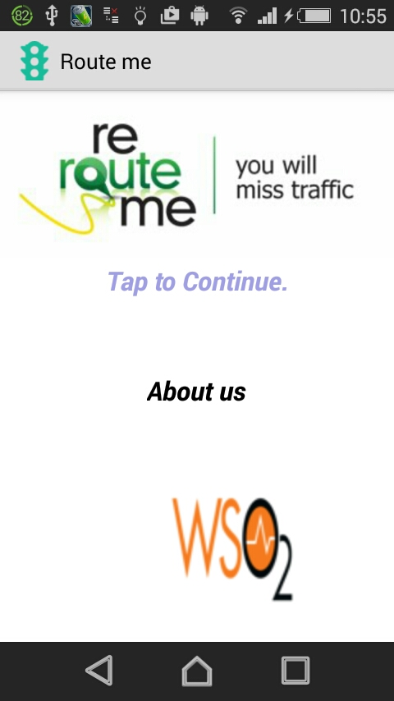
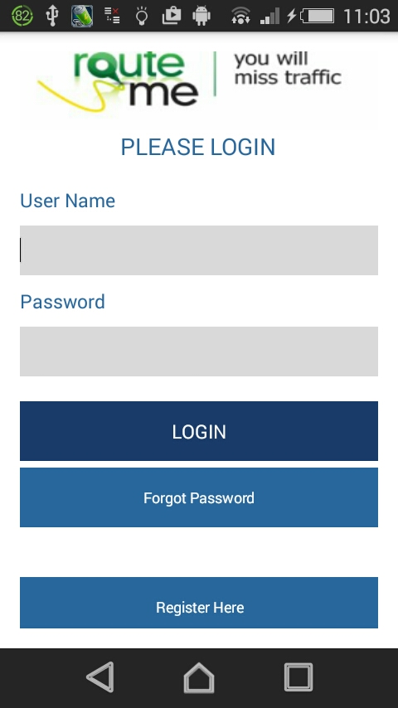
Analysis and design

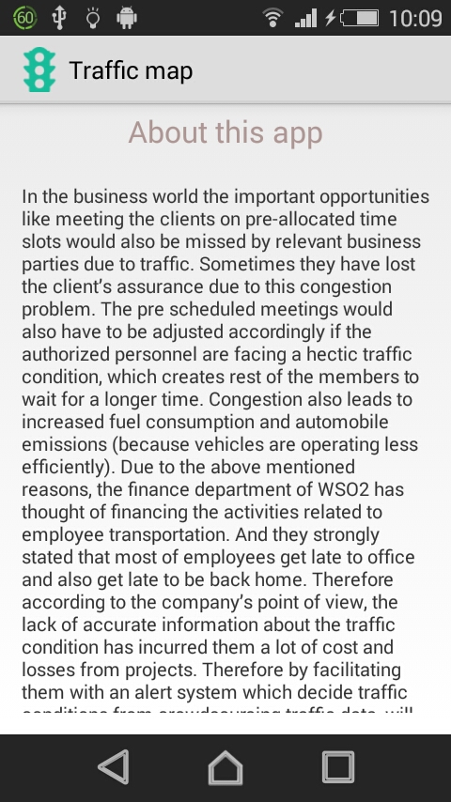
Figure 5.3.2.1 home figure 5.3.2.2 login
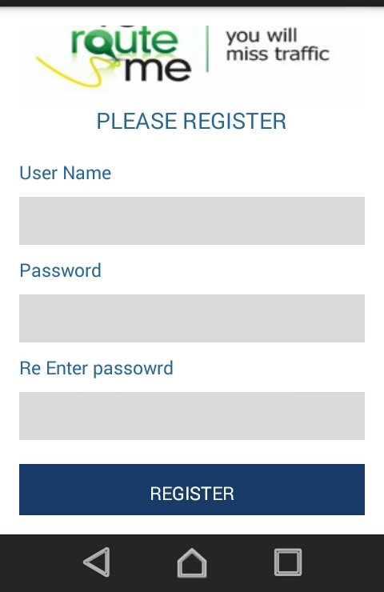
Figure 5.3.2.3 registration figure 5.3.2.4 about us
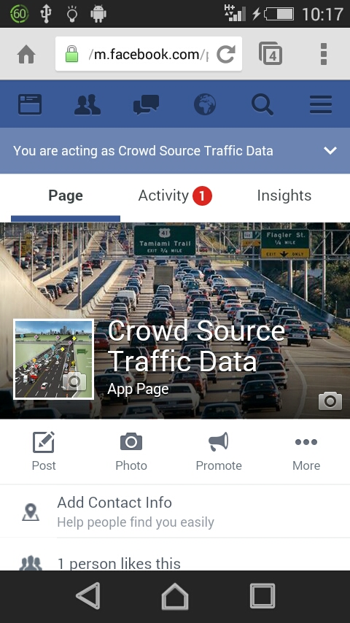
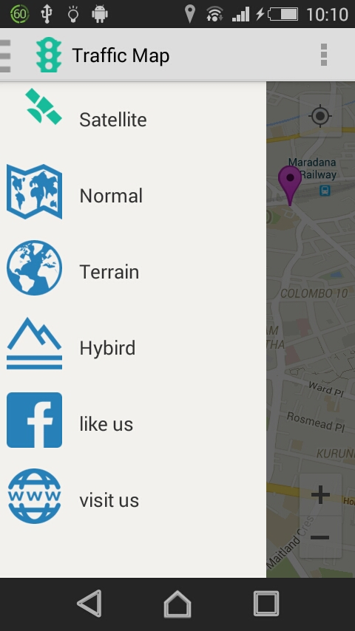
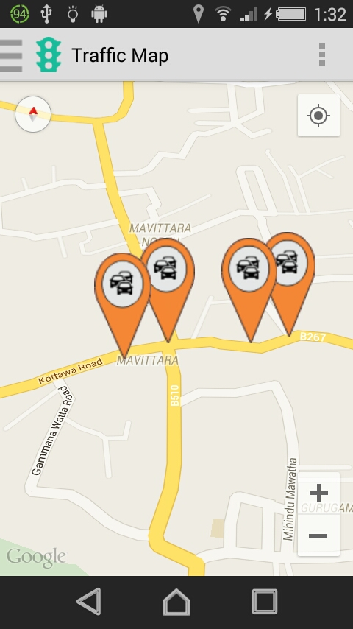
Figure 5.3.2.5 navigation figure 5.3.2.6 facebook like page
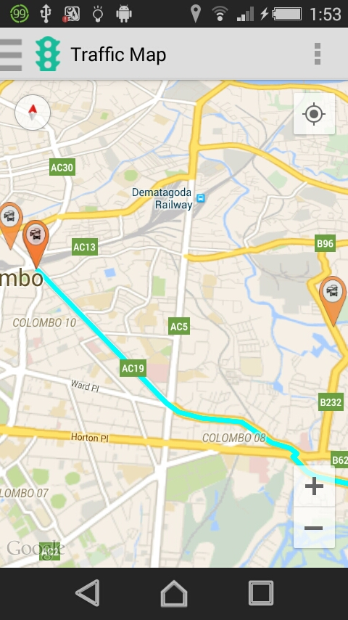
Figure 5.3.2.7 route with navigation Figure 5.3.2.8 traffic on the road
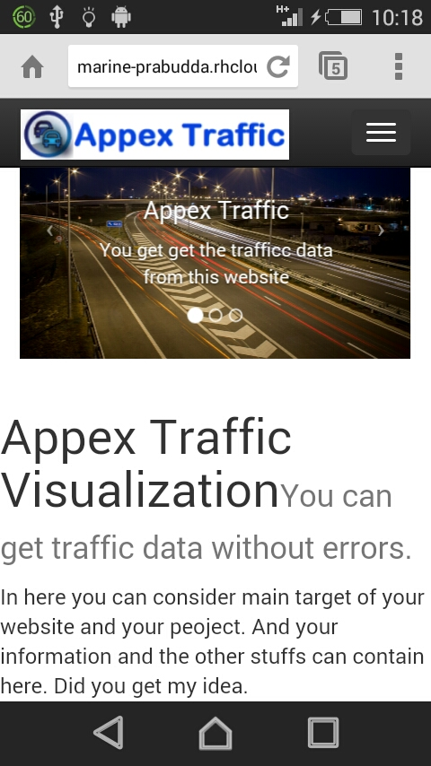
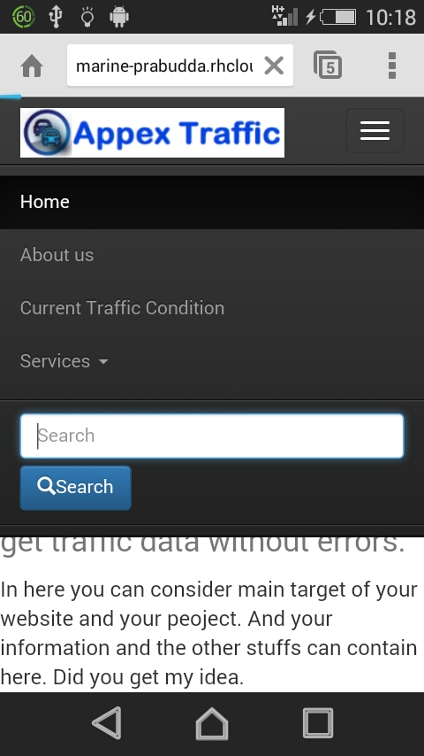

Figure 5.3.2.9 website Figure 5.3.2.10 navigation
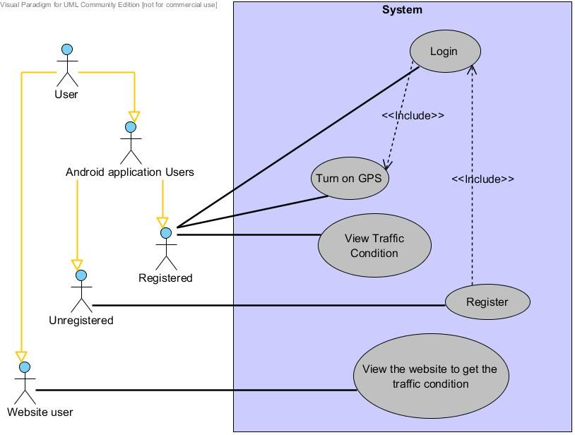
Figure 5.2.1.1 use case diagram
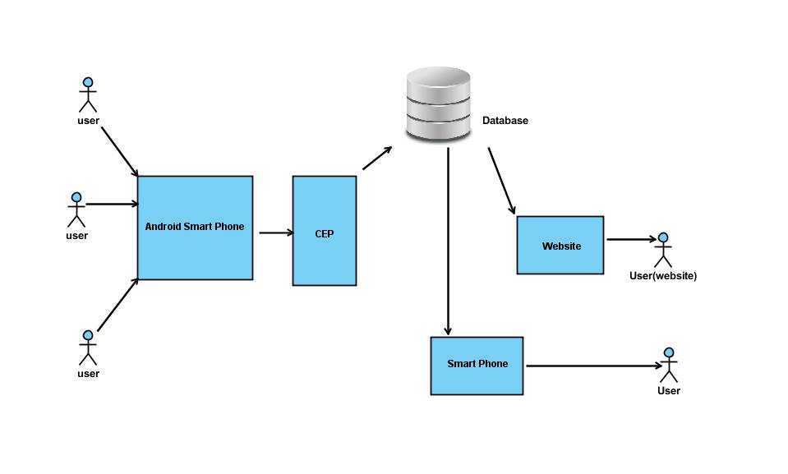
Figure 5.2.1.2 Top level architecture

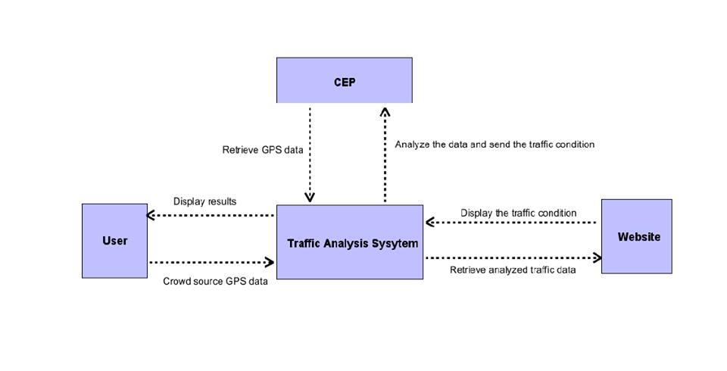

Figure 5.3.1 Context diagram

Appendix ii

Individuals contribution to the project

Name of Student: - P.S.D.I.Nelumdeniya (Registration No: 124118U )

As the leader of our group, firstly I set aims and objectives to my team members and divided tasks among the group members. The part which I got was to analyze the GPS data via CEP. To do that task I referred many research papers related to traffic analyzing topic and I got a thorough understanding about the . And also it was required know about input methods to CEP and output method from the CEP. After having three to four discussions with my team members we came-up with the most appropriate technologies to achieve that task. Also I referred the CEP documentation and executed some sample projects in CEP so that I made myself familiar with siddhi queries. After putting a great effort finally I was able to analyze the GPS data successfully.

Apart from that I made myself familiar with Android,Ecplipse Juno and Android studio. Then I referred about online registration process and the suitable technologies to create online database. Finally I chose “pass” to create a database which can retrieve and store data online. So that I was able to complete the online registration process to our android application.

Finally I contributed to complete the report of our project.

Name of the Student:- K.G.B.Nirmali (Registration No: 124120T)

After the discussion with the company and group members we divided the tasks of the project among us. There were mainly three parts as android application, web site, and data analyzing using CEP. I referred CEP documentation to be familiar with it and executed some samples given in the documentation using siddhi queries.
Me and Ravindi worked together in CEP data analyzing section. After getting a clear understanding about the internal procedure with CEP, we were able to develop an execution plan to analyze data and calculate traffic. I referred many research articles related to traffic analyzing methods. Initially data need to be filtered to identify whether the user is a walker or travelling from a vehicle. For that we developed an algorithm. I got to know that there were standard ways of calculating traffic and out of them we selected LOS as the most appropriate method. To feed data into CEP, client had to be created.
We had to spend more time on segmenting the road and finally we came across with the concept of geo fencing after referring most frequent approaches on GPS data analysis. In between further discussions were made among group members. In the execution plan average speed was calculated and we were able to take an output to indicate the traffic in both directions.
As additional features when it required to add a new junction we can did it using an Admin service to send to CEP and call it through API.
Finally I also contributed to complete the project report.

Name of the Student:- A.R.I. de Silva (Registration No: 124034H)

First we had a discussion with the company. Then we divided the tasks of the project among us into mainly three parts as android application, web site, and data analyzing using CEP. I referred many research articles related to traffic analyzing methods as it was the core part of the project. Then to be familiar with CEP, I referred CEP documentation. As the samples were given in the documentation I executed them to know siddhi query language.
Me and Bhashinee worked together in CEP analyzing part. After getting a clear understanding about the internal procedure with CEP, we were able to develop an execution plan to analyze data and calculate traffic. I referred many articles to find a way to categorize the traffic condition. Out of the standard ways of calculating traffic and out of them we selected LOS as the most appropriate method.
We had to spend more time on segmenting the road and finally we came across with the concept of geo fencing after referring most frequent approaches on GPS data analysis. In between further discussions were made among group members. In the execution plan average speed was calculated and we were able to take an output to indicate the traffic in both directions. To feed data into CEP, client was created using collected data. Output data were published in a web service.
Finally I also contributed to complete the project report.

Name of Student: - M.L.P.Fernando(Registration No: 124056C)

Our main concern was to design and develop an Android application to visualize users the traffic areas and navigate them (using notification markers). My major Contribution is design and develop The Android application and also I contribute to make connectivity with web-servlet and passing data to the CEP. my effort was to design nice interface handle errors of this application(route me) then User can use this application without any interrupts. I also have to Research about to get some information with google API, google map develop with android application development, web-servlet, accessing and retrieving data from database and data transfer Android application and Complex event processor. I also helped others connect Complex event processor with web servlet and their basic steps.
The Application get some information from user, user name and password. And user can log in to the application. I used location manager to get necessary detail in real time and end to the CEP for analyze data.

Name of Student: - G.T.Tharanga(Registration No: 124171A )

I have concerned about the creating the website, retrieve data from main database, embed google map onto the website, visualized the traffic condition on that google map and host that website on openshieft. To create the website I have used Bootstrap and Dreamviewer CS6. I have create a data retrieve php code and run it in xampp. By calling the php file which was host in xampp I could retrieve the data in main database.
First I tried to connect with that main database through .jsp file. But when we connecting with the openshieft there were some problems. So I have selected this way .
Then I visualized that data in my google map in website. I addition to these, we work as a team to achieve our target.

